**Name:__________________________________ Date: __________________________**

**Computer Science | Mr. Eddie**

**Lesson:** U1.L2 - Using Online Search Tools to Locate & Evaluate Information Pt.2

**Objectives:**

* describe various job opportunities, and the role information technology plays in these fields.
* show knowledge of the education level, certification, and skills related to careers they are interested in.

**Do Now:**

*Answer the following questions/prompts;*

1. **What’s a website you often use, and why?**

|  |
| --- |
|  |

1. **What do you like about this website.**

|  |
| --- |
|  |

1. **What’s an application you use on your phone? Is that application available for other devices? If so, what’s the difference?**

|  |
| --- |
|  |

**What is a web developer?**

* A web developer is a programmer who specializes in, or is specifically engaged in the development of World Wide Web applications using a **client–server** model.
  + **Client–server model** is a distributed application structure that partitions tasks or workloads between the providers of a resource or service, called servers, and service requesters, called clients.

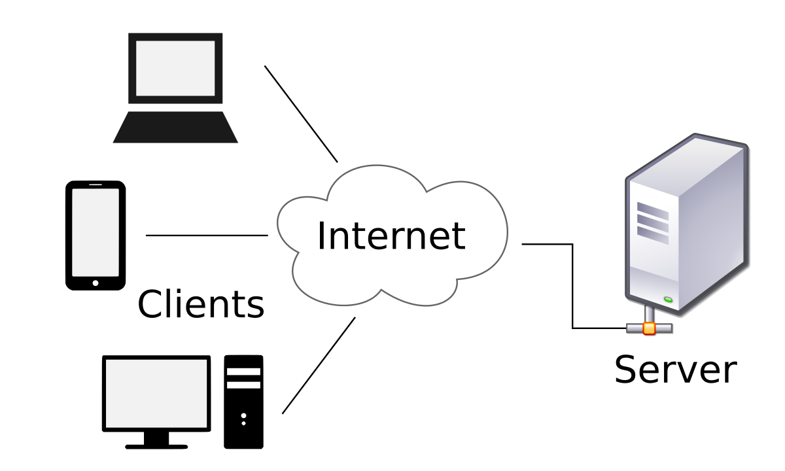

**What is a full-stack developer?**

* A **full stack developer** is an engineer who can handle all the work of databases, servers, systems engineering, and clients. Depending on the project, what customers need may be a mobile**stack**, a Web **stack**, or a native application **stack**.
* **Front-end:** Front-end web development is the practice of converting data to a graphical interface, through the use of HTML, CSS, and JavaScript, so that users can view and interact with that data.
* **Back-end:** A back-end developer is a type of programmer who creates the logical back-end and core computational logic of a website, software or information system. The developer creates components and features that are indirectly assessed by a user through a front-end application or system.

**Is a website an app?**

* **App | Application:** Application is any material, product or a program which is designed for end-user to use.
* **Website**: a location connected to the Internet that maintains one or more pages on the World Wide Web.
* **Web-App**: a web application or web app is a client–server computer program which the client runs in a web browser. Common web applications include webmail, online retail sales, and online auction.

Job Search

|  |  |  |  |
| --- | --- | --- | --- |
| **No.** | **Company** | **Job Title** | **Requirements** |
| **1** |  |  |  |
| **2** |  |  |  |
| **3** |  |  |  |
| **4** |  |  |  |
| **5** |  |  |  |

Based on the job descriptions on the websites you used, what are the different requirements or skills needed between the role of front-end, back-end and front-end developers?

|  |
| --- |
|  |



**Name:__________________________________ Date: __________________________**

**Computer Science | Mr. Eddie**

**Exit Ticket**

1. What is the difference between a front-end and back-end web developer?

|  |
| --- |
|  |

1. What is a full-stack developer?

|  |
| --- |
|  |

1. What is a website?

|  |
| --- |
|  |

1. What questions do you have that were not answered in class?

|  |
| --- |
|  |